**EXP#5 Simulation Guidelines**

**Experiment Admin:**  **Date:**

|  |  |  |  |  |
| --- | --- | --- | --- | --- |
| **Student ID No** | **Name and Surname** | **Points (for Admin)** | | |
| **QZ** | **Expr** | **Total** |
|  |  |  |  |  |

In this experiment, you are going to see the **transient picture** of **RLC circuits**. This is the likely picture one can see when first turning on a circuit. Then after a while, it should disappear. Finally, **the steady-state picture** should take over. To be able to separate both transient and stady-state pictures, one needs to set right waveform with right parameters. In the following simulations, you are going to use **square waveform** with signal frequency based on the **circuit time constant**(τ) or **damping constant** (ζ).

You need to study experiment document first, to get familiar with the subject. You can find all required information in the Lab Manual [1] and referances therein. Be prepared to run simulation on LTspice™ .

Part List from LTSpice Library

(1) Voltage Source: **PULSE**

First, search for “voltage” in the **Part Tool** search box. Then, place it. Finally, set its parameters according to the Table A1.1.

(2) Resistor: **RL**

First, get a draft resistor from the **Tool Bar**; then right-click on **name** and **value** to set them.

(3) Capacitor: **C1**

First, get a drat capacitor from **Part Tool**. Then place it. Finally, right-click on **name** and **value** to set them.

(4) Inductor: **L1**

First, a get draft inductor from **Part Tool**. Then place it. Finally, right-click on **name** and **value** to set them.

(5) Ground: **GND**

Get a ground element from the **Tool Bar**. Then place it on the net.

(6) Label: **Vo**

First, get a draft label from the **Tool Bar**. Then, name it as “Vo”. Finally, place it on the net.

* Wire up your circuit, then run simulation for **transient analysis**.
* To access to measurement results, you need to go to the main menu **View** -> **Spice Error Log** -> Copy results
* To display graphs, you need to position **Voltage or Current probe** on the circuit element in the schematic.

**Osillator Settings:**

* **Waveform: Square Wave**
* **Ampitude (pp): 5 V**
* **Frequency: 1k Hz (Half Priod: TON =TOS /2= 0.5 ms)**

(A) RC circuit measurement

**Circuit: Refer to Fig. 5.1**

Run transient analysis of the following circiut for C1= 10 nF, R1: according to tabulated values

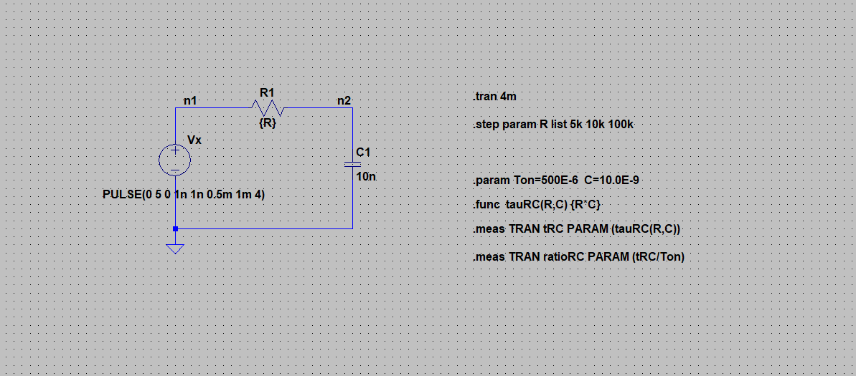

**Report Requirements**

* Include **time constant** (**tRC**) and its **ratio** from Spice Error Log
* Include capacitor voltage (VC ) waveforms
* Fill out **Table A.1**
* Include **date** and **time** from Spice Error Log

|  |  |  |  |
| --- | --- | --- | --- |
| **Table A.1** | | | |
| **Steps** | **R1** | **Calculate Time Constant [s]** | **Calculate the followings ratio** |
| **1** | **R11 = 5kΩ** | **τC1 = [μs]** | **τC1 /TON =** |
| **2** | **R12 = 10kΩ** | **τC2 = [μs]** | **τC2 /TON =** |
| **3** | **R13 = 100kΩ** | **τC3 = [μs]** | **τC3 /TON =** |

V(C)

(B) RL circuit measurement

**Circuit: Refer to Fig 5.7**

**Osillator settings:** as in Section-A

Run transient analysis of the following circiut for L2= 100 mH, R1: according to tabulated values

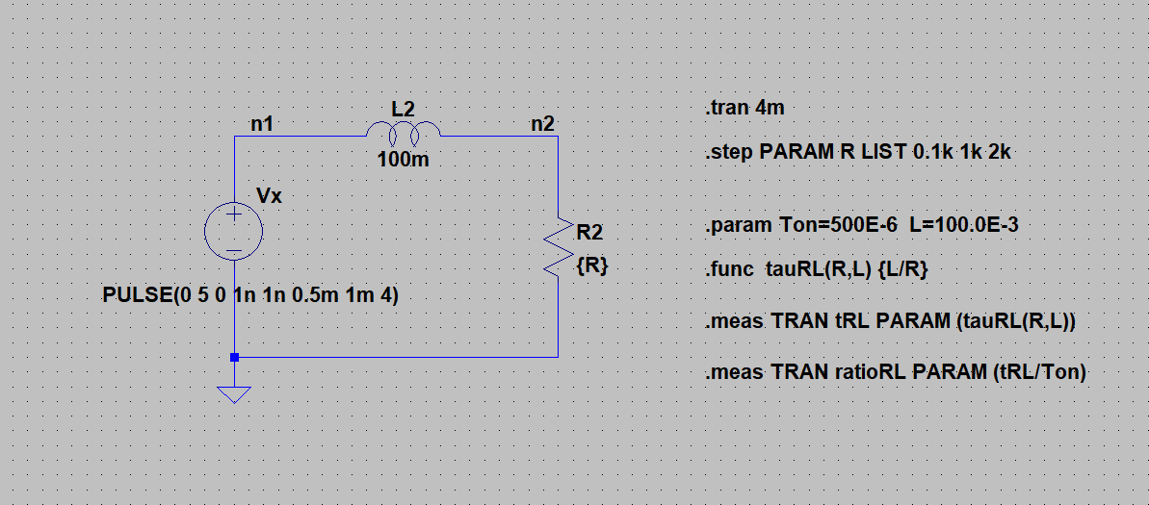

**Report Requirements**

* Include **time constant** (**tRC**) and its **ratio** from Spice Error Log
* Include **date** and **time** from Spice Error Log
* Include resistor voltage (VR ) waveforms
* Fill out **Table B.1**

|  |  |  |  |
| --- | --- | --- | --- |
| **Table B.1** | | | |
| **Steps** | **R2** | **Calculate Time Constant [s]** | **Calculate the followings ratio** |
| **1** | **R21 = 0.1kΩ** | **τL1 = [μs]** | **τL1 /TON =** |
| **2** | **R22 = 1kΩ** | **τL2 = [μs]** | **τL2 /TON =** |
| **3** | **R23 = 2kΩ** | **τL3 = [μs]** | **τL3 /TON =** |

V(R)

(C) RLC circuit measurement

**Circuit: Refer to Fig 5.8**

**Osillator settings:** as in Section-A

Run transient analysis of the following circiut for L3= 10 mH; C3=10 nF; R3: to set damping factor, **ζ**=(R/2)√(C/L)

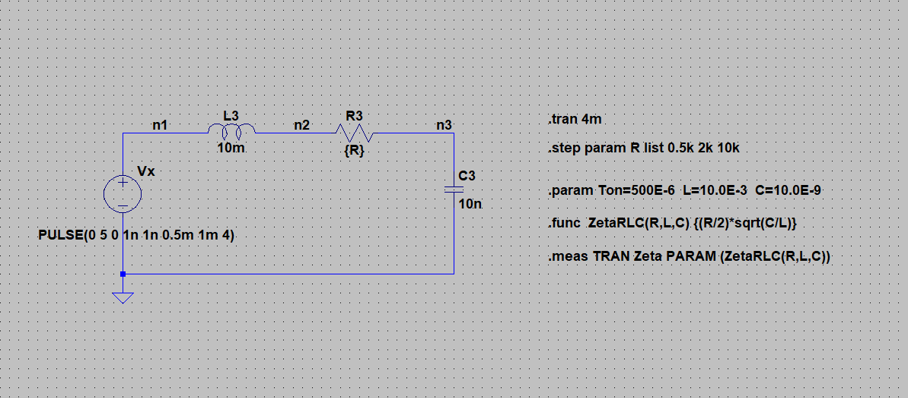

**Report Requirements**

* Include **damping factor** (**ζ1**) from Spice Error Log
* Include **date** and **time** from Spice Error Log
* Include capacitor voltage (VC ) waveforms
* Fill out **Table C.1**

|  |  |  |  |
| --- | --- | --- | --- |
| **Table C.1** | | | |
| **Steps** | **R3** | **Calculated ζ Constant** | **Evaluate each damping factor**  **as Under , Over or Critical** |
| **1** | **R31 = 0.5kΩ** | **ζ1 =** |  |
| **2** | **R32 = 2kΩ** | **ζ2 =** |  |
| **3** | **R33 = 10kΩ** | **ζ3 =** |  |

V(C)

**References**

[1] Basics of Electrical Circuits Lab Manual, ITU, online, 2013.

**Please report any error to** [**ozayan@itu.edu.tr**](mailto:ozayan@itu.edu.tr) **[R2021.1, Ayan Derya]**